1/1/2024

Humaka

**Process Wire CMS**

**Installation Manual**

Contents

1. Introduction 3

1.1 Overview 3

1.2 Purpose of the installation manual 3

1.3 Target audience and prerequisites 3

2. System Requirements 4

3. Installation Procedure 6

4. Technical Support and Contact Information 16

# Introduction

## 1.1 Overview

ProcessWire CMS is a user-friendly platform designed to facilitate website creation and management without requiring advanced technical skills. It enables you to efficiently organize content, customize layouts, and ensure website security and performance. With its image manipulation capabilities and multi-language support, it empowers users to create dynamic and versatile websites. In essence, ProcessWire CMS simplifies the website development process, making it accessible to individuals without extensive technical expertise.

## Purpose of the installation manual

The purpose of the installation manual is to provide users with a comprehensive and structured guide for successfully installing ProcessWire CMS. This document aims to simplify the installation process, making it accessible even to individuals without advanced technical knowledge. By following the step-by-step instructions, users will be able to set up the system effectively, ensuring a smooth and error-free installation experience. The manual also serves as a reference point for configuring settings, testing the installation, and seeking technical support or additional resources if needed. Overall, the installation manual serves as a valuable resource to assist users in getting started with ProcessWire CMS.

## Target audience and prerequisites

The installation manual is intended for a diverse audience, including web developers, administrators, and individuals responsible for setting up and managing websites or web applications. It caters to both technical and non-technical users, aiming to provide clear and accessible guidance for installing ProcessWire CMS.

**Prerequisites:**

To successfully install ProcessWire CMS, users should have a basic understanding of web technologies, web hosting environments, and fundamental server management concepts. While the installation process is designed to be user-friendly, familiarity with web servers, databases, and file management is beneficial, specifically, users should meet the following prerequisites:

* **Web Hosting Environment:** Access to a web hosting environment or server where ProcessWire CMS will be installed. This environment should support PHP (version 7.0 or higher) and have a MySQL or MariaDB database available. Alternatively, for local development and testing purposes, users can set up a local server environment using WAMP (Windows) or MAMP (Mac).
* **Domain or Subdomain:** A registered domain name or subdomain where the website will be hosted and accessible to users.
* **WAMP (Windows) or MAMP (Mac):** For users intending to set up a local development environment on Windows, the installation of WAMP (Windows, Apache, MySQL, PHP) or a similar local server stack is required. For Mac users, MAMP can be used. These stacks provide a local server environment for development and testing.
* Text Editor or Integrated Development Environment (IDE): A text editor like Visual Studio Code or PhpStorm by Intellij for making configuration changes, customizing settings, and working with code, if required.
* Internet Connectivity: Access to the internet to download the ProcessWire CMS files and check for updates or additional resources.

These prerequisites ensure a smooth installation process and enable users to set up, customize, and manage ProcessWire CMS effectively. Integrated Development Environments (IDEs) like Visual Studio Code and PhpStorm offer enhanced code editing and development capabilities for users who prefer a more feature-rich environment. Additionally, the information regarding non-Apache servers provides guidance for those who wish to deploy ProcessWire on alternative web server platforms.

# System Requirements

* **Web Server:** Unix, Windows-based web server (Apache recommended, others supported).
* PHP: PHP 8.x or newer recommended (PHP 7.x versions also supported).
* **Database:** MySQL 5.6 or newer recommended (MariaDB also supported).
* **Apache Configuration:** Apache must have mod_rewrite enabled and support .htaccess files.
* **Image Processing:** PHP's bundled GD 2 library or PHP IMagick (ImageMagick).
* **Web Hosting Environment:** Access to a web hosting environment or server supporting PHP (version 7.0 or higher) with a MySQL or MariaDB database.
* **Domain or Subdomain:** A registered domain name or subdomain for hosting the website.
* **Local Development Environment (Optional):** Users may set up a local server environment using WampServer (WAMP) for testing.
* **Text Editor or IDE:** Utilize a text editor like Visual Studio Code or PhpStorm for configuration and coding.
* **Database Access:** Provide credentials (username and password) for MySQL or MariaDB, granting table creation and data management permissions.
* **Internet Connectivity:** Ensure internet access for downloading ProcessWire CMS files and checking for updates or additional resources.
* **Hardware:** **Modern processor (e.g., Intel Core i3 or equivalent), 2 GB of RAM or more, minimum 200 MB of free disk space.**
* 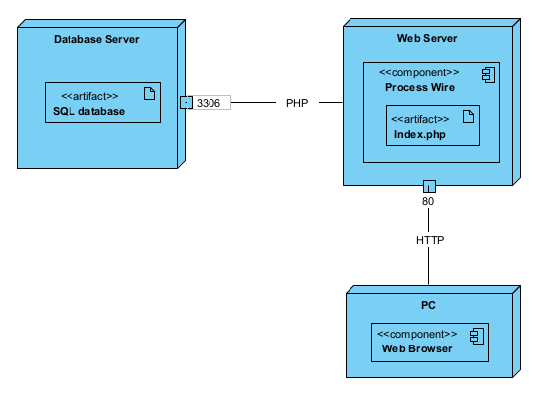**Deployment Diagram:**

# Installation Procedure

To begin the installation of WampServer, please follow these steps:

1. Visit the official WampServer website at https://wampserver.aviatechno.net/.
2. Navigate to the "Downloads" section and locate the "All VC Redistribuable Packages (x86_x64) (32 & 64bits)" section. Download and install all the VC Redistributable Packages listed here. Ensure you download the versions compatible with your system (32-bit or 64-bit).

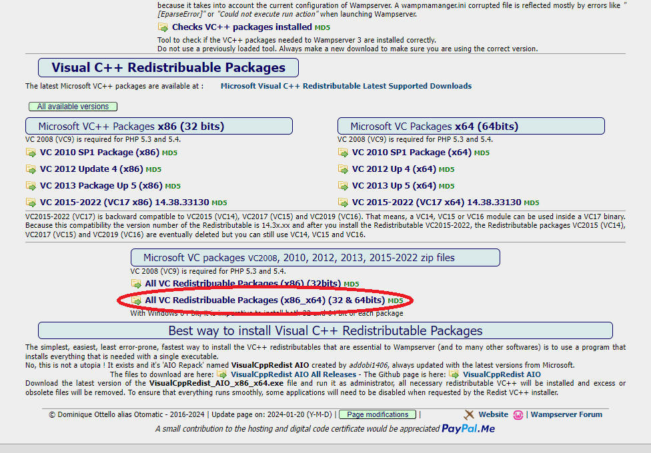

1. Next, proceed to download the latest version of WampServer by clicking on the link that corresponds to your system configuration

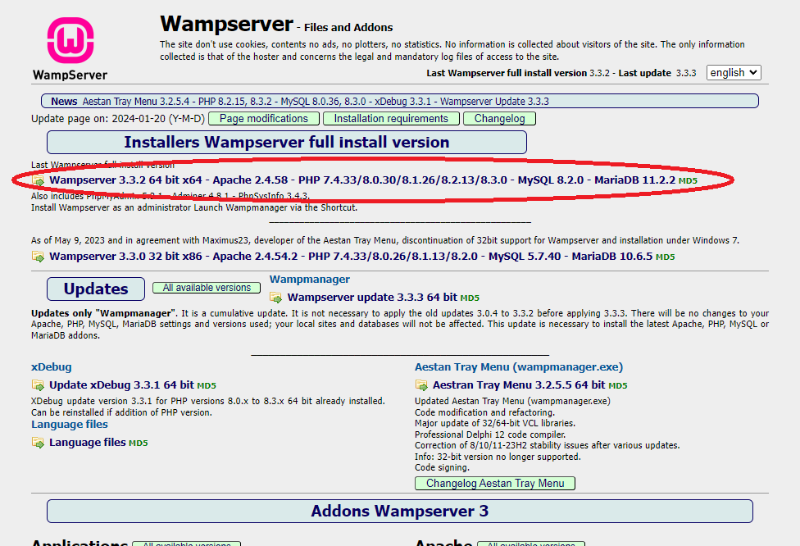

1. Once the download is complete, run the installer for WampServer and follow the on-screen instructions to install the software on your system.
2. To download the ProcessWire CMS core files, please visit the official ProcessWire website at https://processwire.com/download/core/ and click the "Download" button on the page. This will initiate the download of the latest version of ProcessWire to your computer.

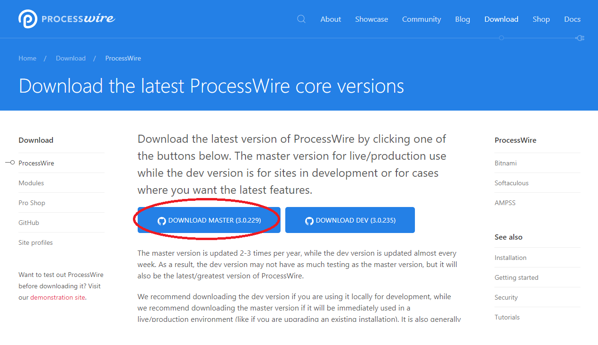

1. Delete all contents within the "C:\wamp\www" directory.
2. Extract the downloaded ProcessWire CMS files directly into the "C:\wamp\www" directory.

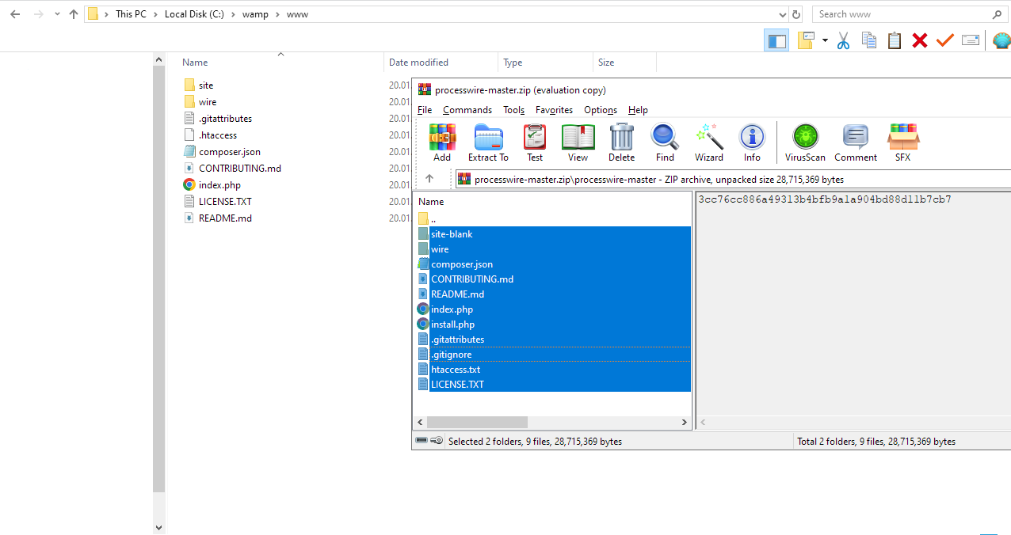

1. Launch WampServer by opening the application.
2. Open your web browser and navigate to "localhost", the following welcome message should be visible, proceed by clicking on „Get Started”.

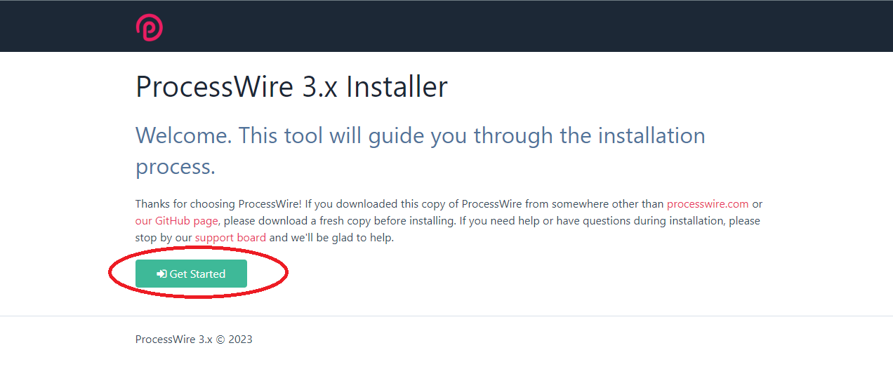

1. Select the "blank" option for the installation profile and click "Continue."

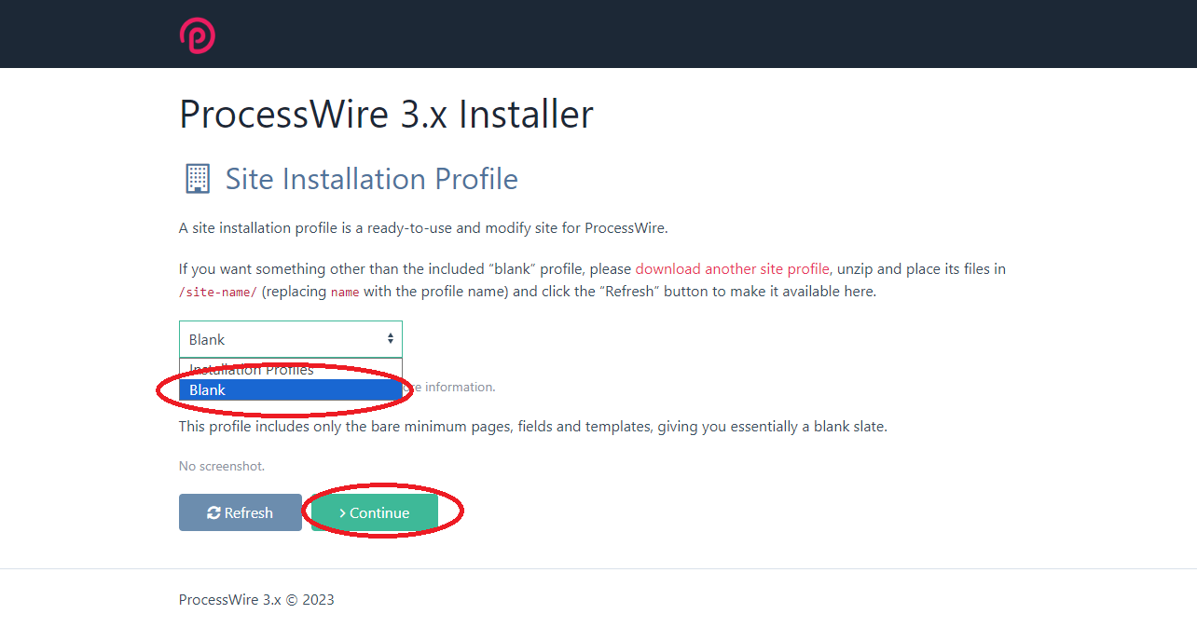

1. The system will perform a compatibility check. If anything is found to be uninstalled, please install it and return to this step. Then, press "Continue" to proceed to the next step.

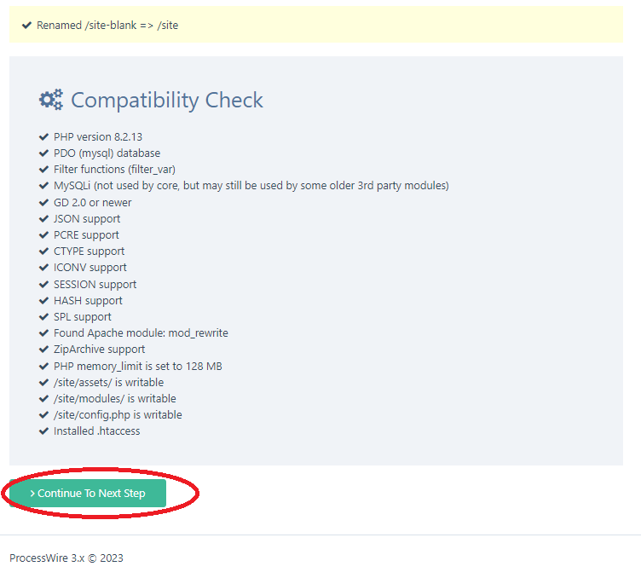

1. Choose a database name, preferably "ProcessWire." Enter the username and password for your database; the default values are "root" for the username and a blank password. Select your time zone, leaving other settings untouched, and click "Continue."

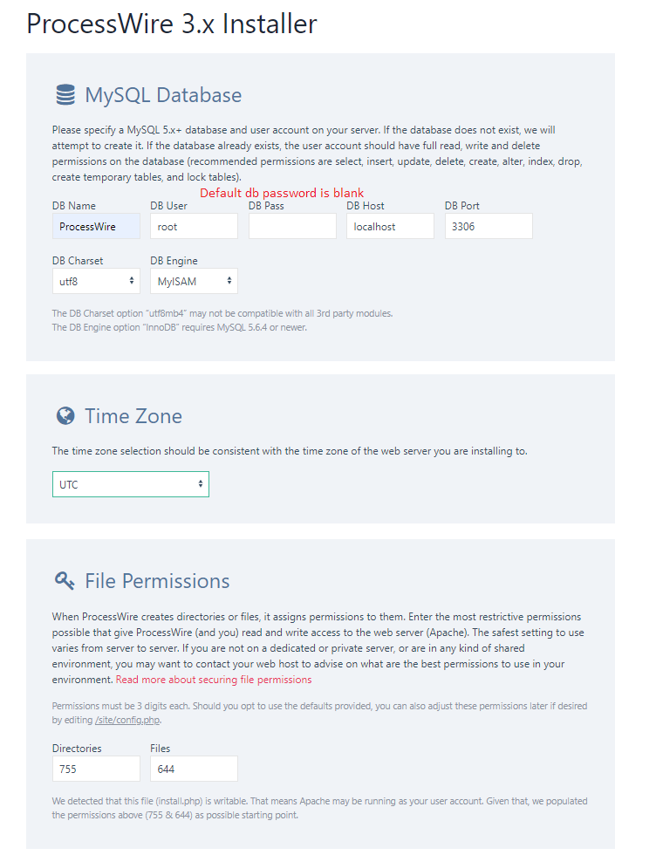

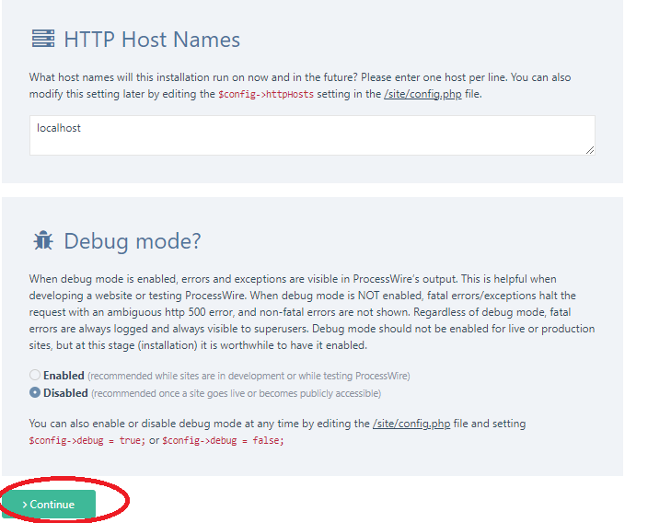

1. A success message should appear, confirming the successful creation and configuration of the database.

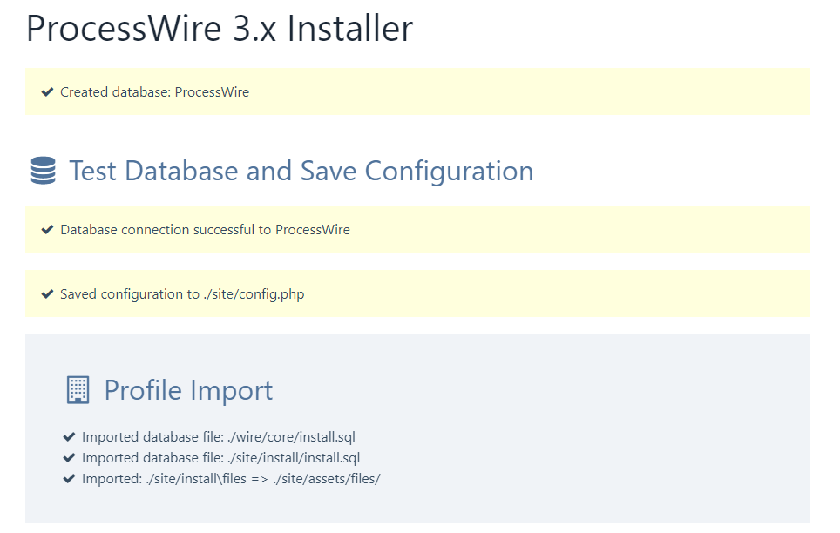

1. Now, it's time to configure your admin account, which you'll use to access the software as an administrator. The admin login URL is the gateway to the admin panel. Ensure you select an admin username and a strong password with a minimum of 6 characters.

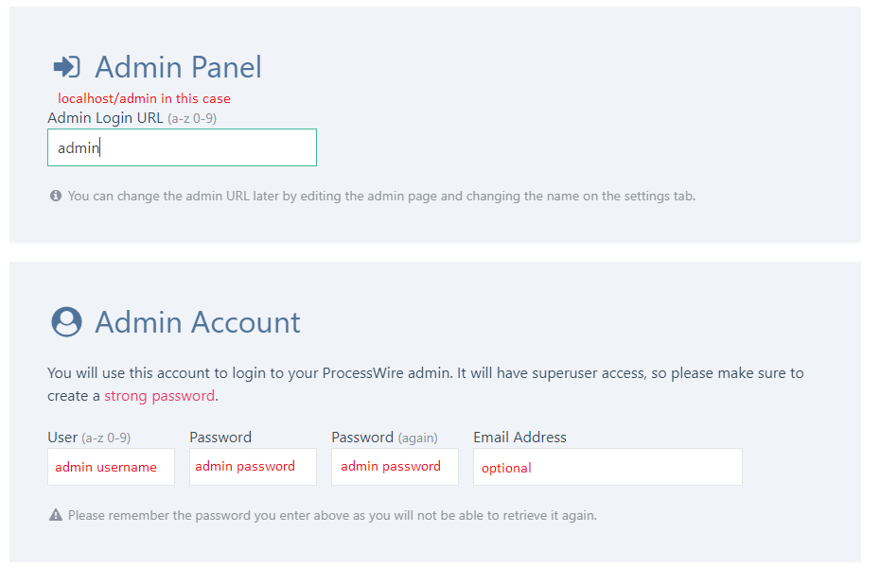

1. Check all the boxes in the cleanup section and click "Continue".

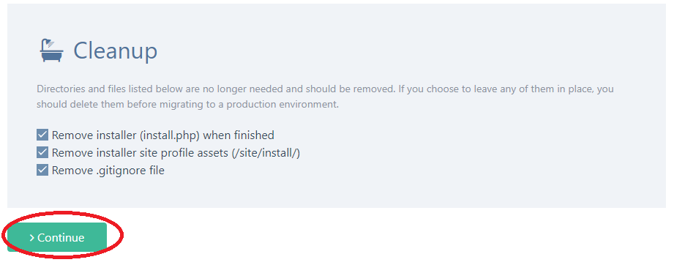

1. You should receive a message indicating that your admin account was successfully created. Click on "Login to Admin" to proceed.

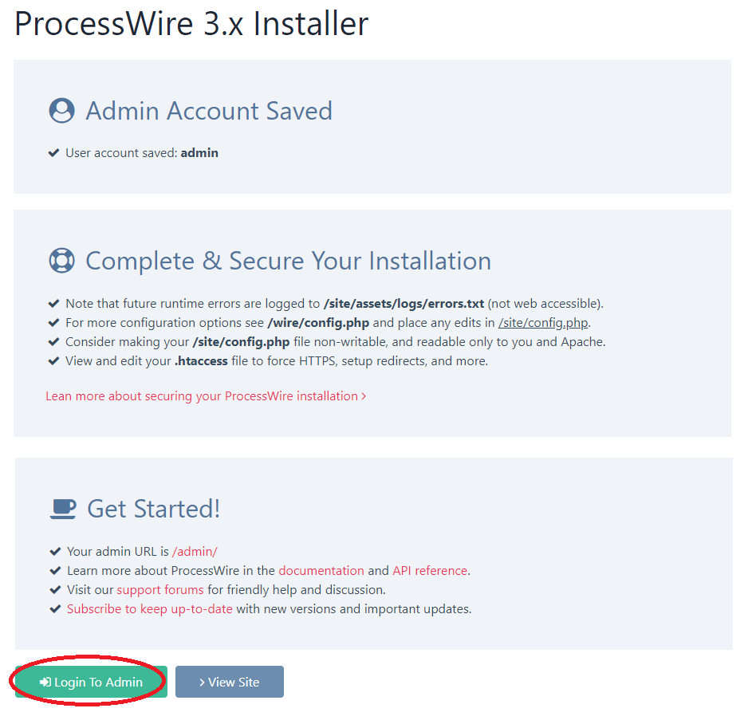

1. Enter the admin credentials you've just created.

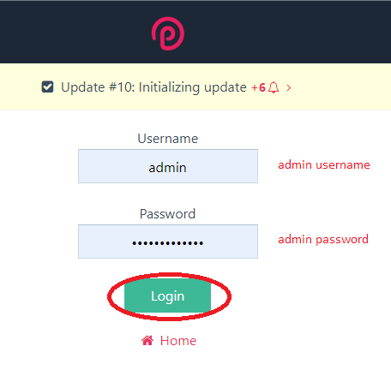

1. You are now on the admin page, and you can start using the system.

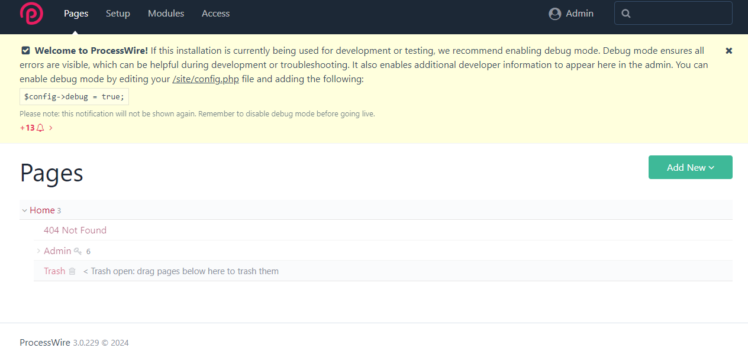

# Technical Support and Contact Information

* **Forum:** Access our community forum for discussions, assistance, and collaboration at [ProcessWire Forum](https://processwire.com/talk/).
* **Documentation:** Explore comprehensive documentation and resources for ProcessWire CMS at [ProcessWire Documentation](https://processwire.com/docs/).
* **Contact:** For direct inquiries or additional support, please visit our [Contact Page](https://processwire.com/about/contact/).